Snowflake Hands-On

**Name : NAGURU MOUNIKA**

**Emp ID : 2320670**

* Create a database and Table and Insert data.

* Alter table and Update table.

* Delete employee_id =2 from table.

* Clone the table.

* Create view table.

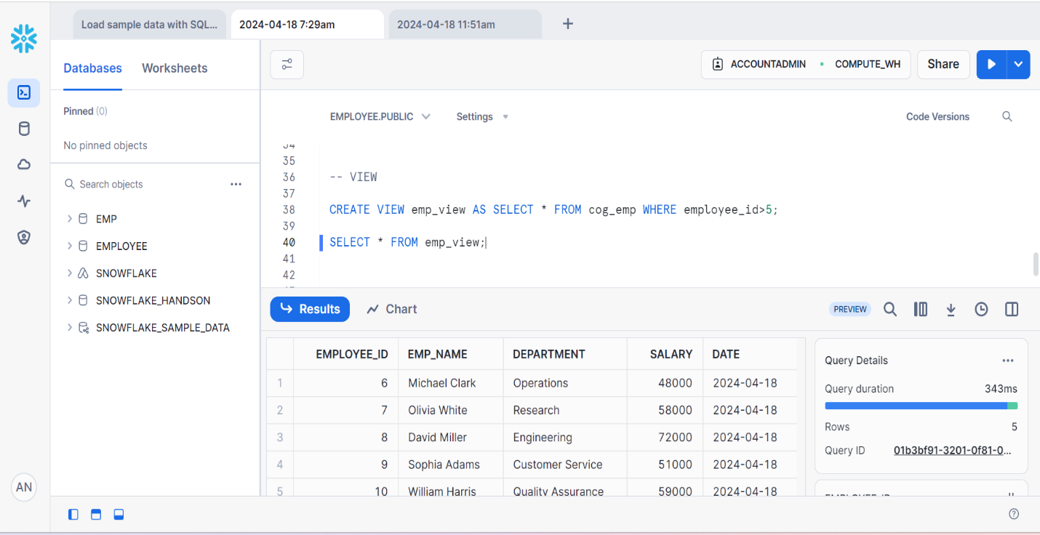

* Drop the table.

* Undrop the table.

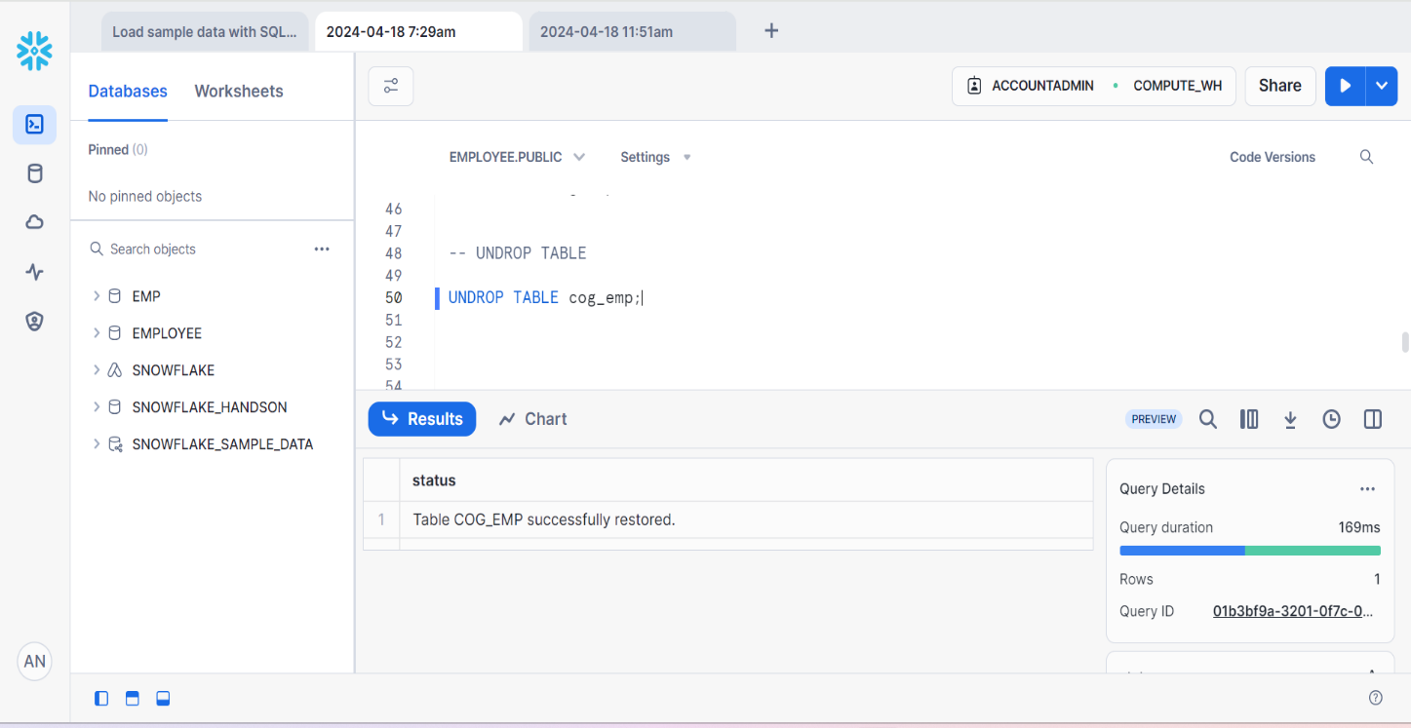

* Performed Time-Travel.



